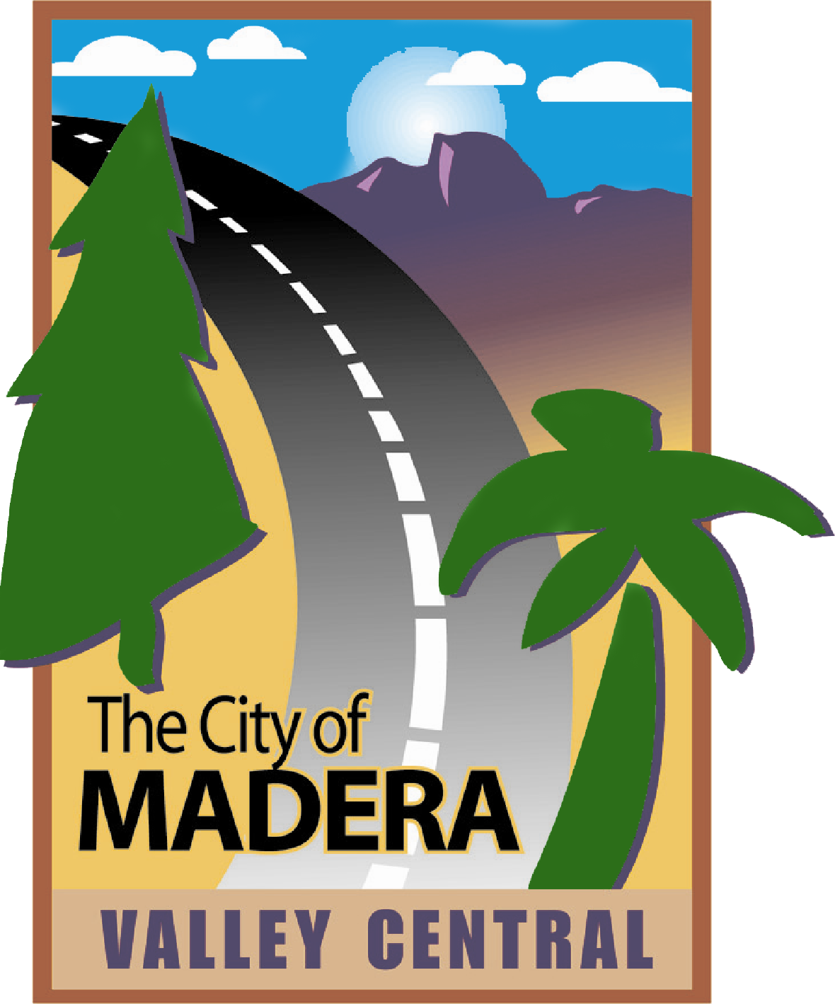
REGULAR MEETING AGENDA

CITY OF MADERA
ZONING ADMINISTRATOR PERMIT

CONFERENCE ROOM
CITY HALL
MONDAY
July 12, 2021
2:00 pm

CALL TO ORDER

PUBLIC COMMENT

The first fifteen minutes of the meeting are reserved for members of the public to address the Commission on items which are within the subject matter jurisdiction of the Commission. Speakers shall be limited to three minutes. Speakers will be asked to identify themselves and state the subject of their comment. If the subject is an item on the Agenda, the Chairperson has the option of asking the speaker to hold the comment until that item is called. Comments on items listed as a Public Hearing on the Agenda should be held until the hearing is opened. The Commission is prohibited by law from taking any action on matters discussed that are not on the Agenda and no adverse conclusions should be drawn if the Commission does not respond to public comment at this time.

PUBLIC HEARING ITEMS

ZAP 2021-03 – Dee Dee’s Boutique
A noticed public hearing to consider a request for a Zoning Administrator Permit to allow for sales of new and used clothing and shoes at 1301 W. Olive Ave. Ste. E. The site is located in the C1 (Light Commercial) Zone District with a C (Commercial) General Plan land use designation. APN: 010-061-001

The Planning Department reviewed the project in accordance with the requirements of the California Environmental Quality Act (CEQA) and determined that the project falls within the Class 1 Categorical Exemption set forth in the CEQA Guidelines Section 15301 as the project involves a use permitting in an existing structure with no proposed modifications. Furthermore, none of the exceptions to Categorical Exemptions set forth in CEQA Guidelines Section 15300.2 apply to this project. (Report by Adam Klier)

COMMITTEE MEMBER COMMENTS/REPORTS

ADJOURNMENT

