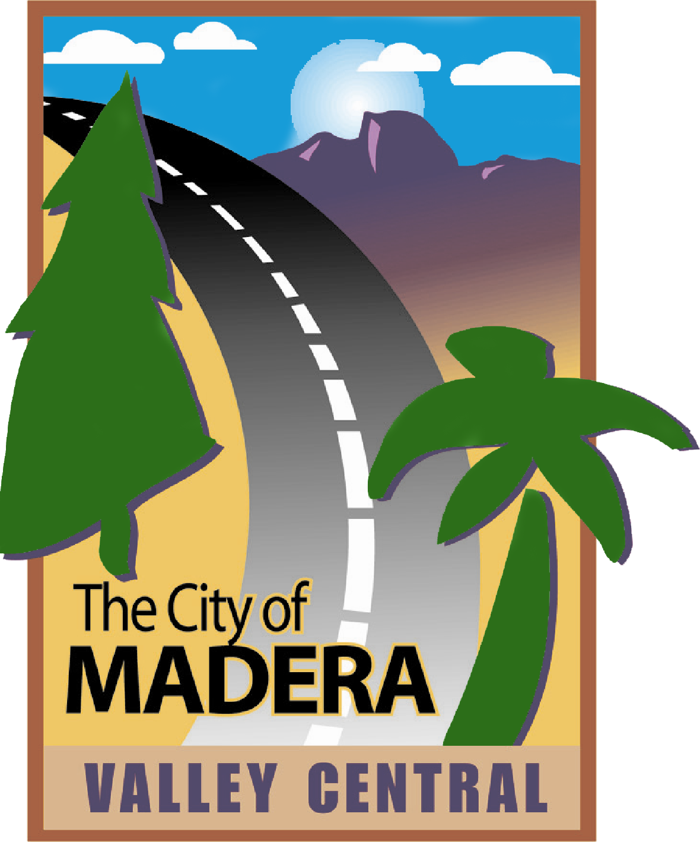
REGULAR MEETING AGENDA

CITY OF MADERA
ZONING ADMINISTRATOR PERMIT

CONFERENCE ROOM
CITY HALL
TUESDAY
February 2nd, 2021
3:30 pm

This meeting will be conducted pursuant to the provisions of the Governor’s Executive Order which suspends certain requirements of the Ralph M. Brown Act. Members of the public may participate in the meeting remotely through an electronic meeting in the following ways: via phone by dialing (669) 900-6833 enter ID 96325847402 followed by *9 on your phone when prompted to signal you would like to speak, or by computer at https://www.zoom.us/j/96325847402. Public comment will also be accepted via email at zap@madera.gov.

CALL TO ORDER

PUBLIC COMMENT

The first fifteen minutes of the meeting are reserved for members of the public to address the Commission on items which are within the subject matter jurisdiction of the Commission. Speakers shall be limited to three minutes. Speakers will be asked to identify themselves and state the subject of their comment. If the subject is an item on the Agenda, the Chairperson has the option of asking the speaker to hold the comment until that item is called. Comments on items listed as a Public Hearing on the Agenda should be held until the hearing is opened. The Commission is prohibited by law from taking any action on matters discussed that are not on the Agenda and no adverse conclusions should be drawn if the Commission does not respond to public comment at this time.

PUBLIC HEARING ITEMS

ZAP 2021-01 – Lot 30 Reduced Rear Yard Setback
Review of an application for a Zoning Administrator Permit (ZAP) to allow for construction of a residence (886 Bent Oak Trail) with a rear yard structural setback of 12 feet in the PD-6000 zone district with an LD (Low Density) General Plan land use designation. Approval of the ZAP would allow for a 3-foot encroachment into the required fifteen foot (15’) rear yard structural setback.

This project has been determined to be categorically exempt under the California Environmental Quality Act (CEQA) Guidelines, Section 15305, (Minor Alterations in Land Use Limitations).

ZAP 2021-02 – Fast Track Car Wash Solar
An application for a Zoning Administrator Permit (ZAP) to allow for the installation of new solar, including a shade structure and roof mounted panels at an existing Fast Track Car Wash site located at 127 S. Pine St. in the C1 (Light Commercial) Zone District with a C (Commercial) General Plan land use designation.

This project has been determined to be categorically exempt under the California Environmental Quality Act (CEQA) Guidelines, Section 15301 (Existing Facilities) and Section 15304, (Minor Alterations to the Land).

COMMITTEE MEMBER COMMENTS/REPORTS

ADJOURNMENT

